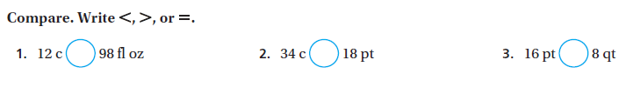Name _________________________________________ Period______ **2/22/17** **Customary Weight & Capacity Conversions**





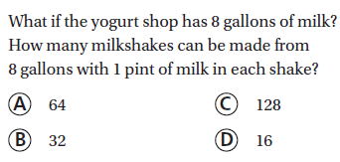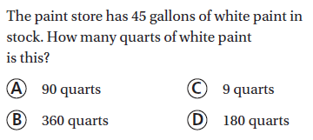

8.

7.

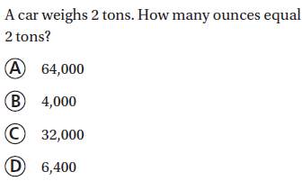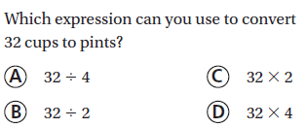

9.

10.

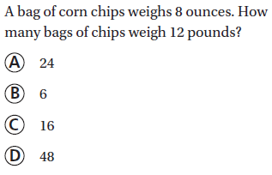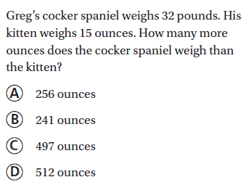

12.

11.