Name _________________________________________ Period______ **2/21/17** **Customary Conversions- Length**









9.

8.

7.

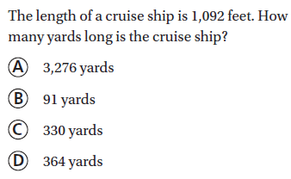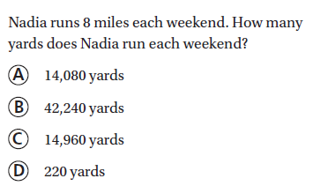

10.0.

11.

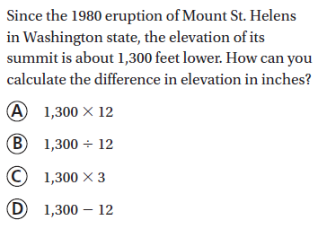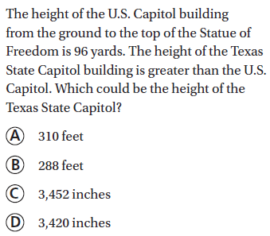

12.

13.