Name __________________________ Date __________ Period ______
Heading to 6th Grade!
Daily Skill 3 (Mixed Fraction Review)

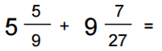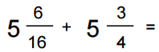
2.
1.

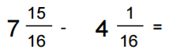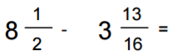
4.
3.

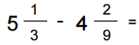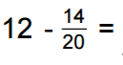
6.
5.

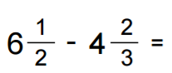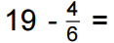
8.
7.

