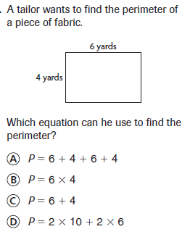

**1.**

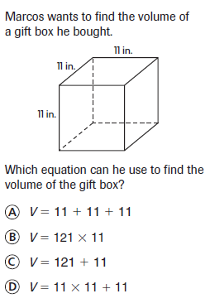

**4.**

**2.**

**5..**

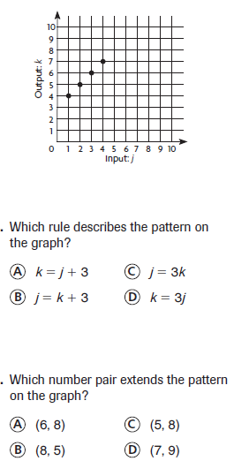

**3.**

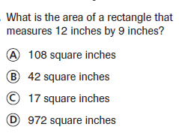



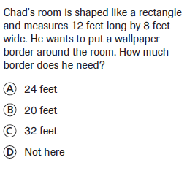

**9..**

**6..**

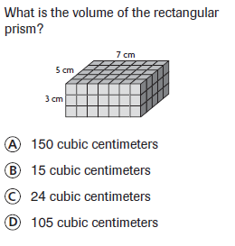

**7..**

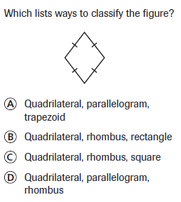

**8..**

**10..**

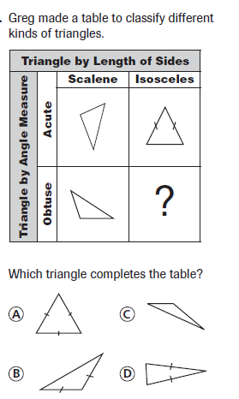

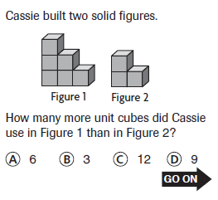

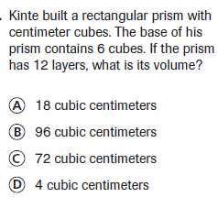

**14..**

**11..**

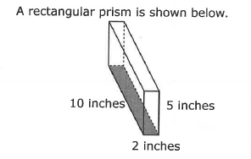

**12..**

**15..**

What is the area of the base of the prism?

**100 square inches 20 square inches**

**100 cubic inches 20 cubic inches**

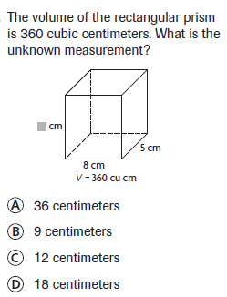

**16..**

**13..**

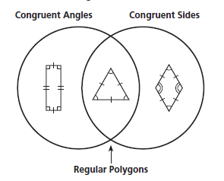

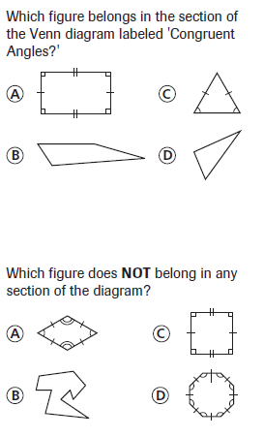

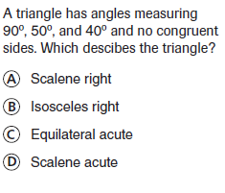

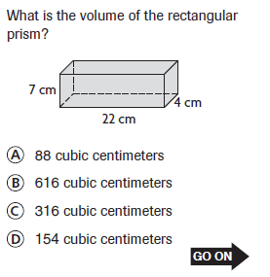

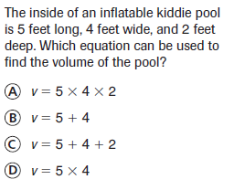

**17..**

**21..**

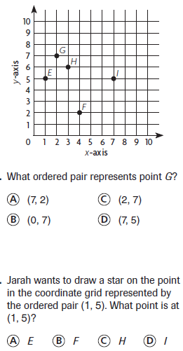

**18..**

**19..**

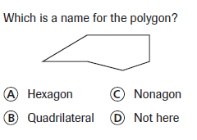

**20..**

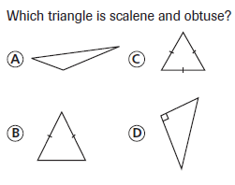

**22.** Exactly 5 layers of cubes will fit inside the container shown. What is the volume of the container?

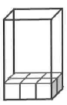





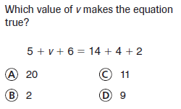

**23..**

**24. Which figure is described by the geometry model below?**

**Polygon**

**Quadrilateral**

**2 Sets of Parallel Sides**

**4 Right Angles**

**4 Equal Sides**

**Si**

**?**



**Rhombus**

**Trapezoid**

**Square**

**Equilateral Triangle**

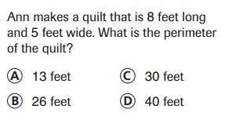

**25.**

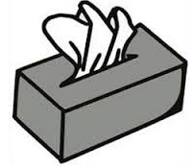**26. A tissue box has a length of 9 inches, a width of 5 inches, and a height of 4 inches.**

**Which of the following is not true?**



**The volume of the tissue box is 180 cubic inches.**

**The area of the base is 36 square inches.**

**The perimeter of the base is 28 inches.**

**The height of the box is 1/3 of a foot.**

