Name __________________________ Date __________ Period ______
Heading to 6th Grade!
Daily Skill 2 (Subtracting Mixed Numbers)

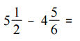
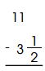
5. 6. ____________________

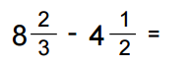
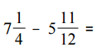
7. _______________ 8. ________________

