Name __________________________ Date __________ Period ______
Heading to 6th Grade!
Daily Skill 6 (Multiplication)
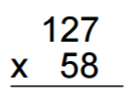
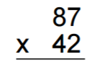
2.
1.

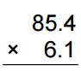
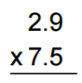
4.
3.

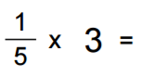
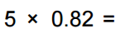
6.
5.

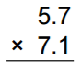
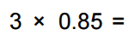
8.
7.

